Circuit diagram for proposed line sensors

­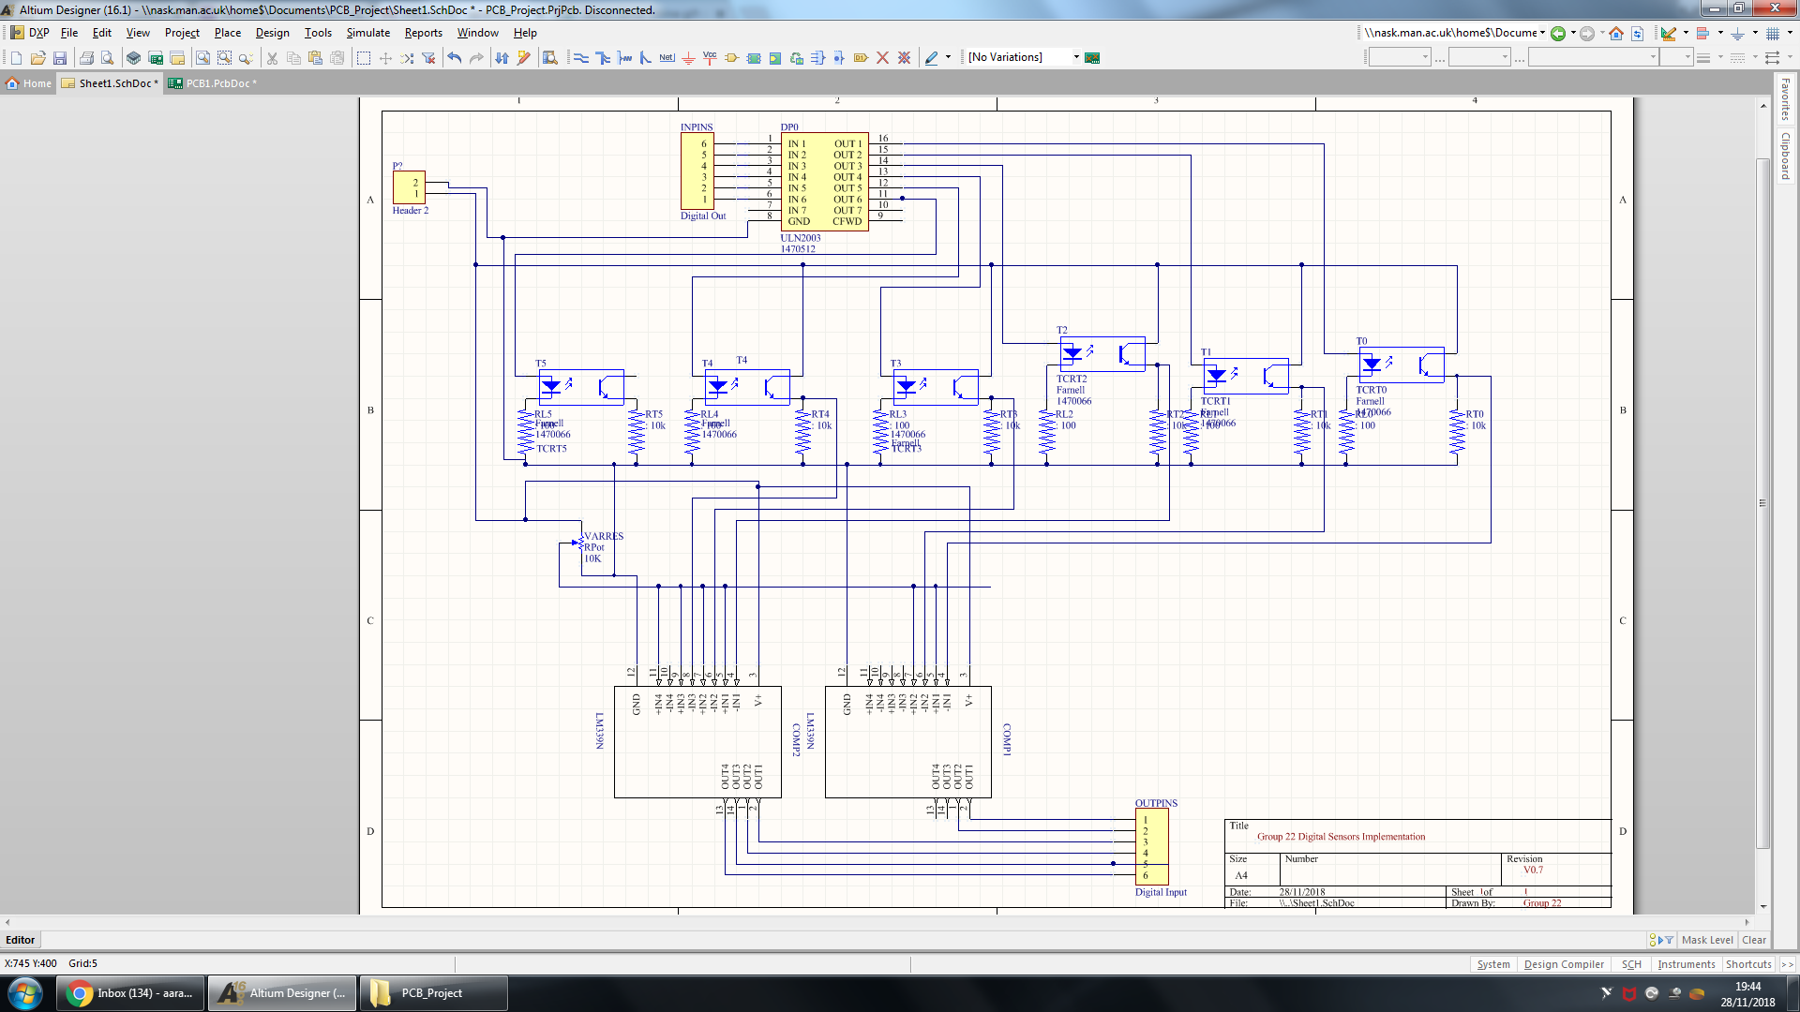

Figure 4.1 Section of schematic showing input signals of the sensor board.

Choosing the method of implementation and sensor configuration is justified in ­Control. The group decided to implement digital sensors. This means the sensor board will be interfacing with the microcontroller using digital inputs and outputs. As these DIO pins are limited to 5 V 4 mA, this is insufficient power to power the LEDs. The LEDs will therefore be powered by power rails from the motor driver board. A 7n element Darlington Pair chip ULN2003A is being used which will allow both independent control of LEDs and also provide the LEDs with sufficient current to be powered on. Pins 1 to 6 of the Darlington Pair are connected to the Digital Out pins from the microcontroller. The Darlington Pair is powered by the driver board to pin 10. The following pins 11 to 16 are connected to each individual LEDs. The transistors can be connected directly to the driver board as they do not draw as much current as the LEDs.



Figure 4.2 Section of schematic showing how LEDs, transistors and resistors connected. The LEDs are in series with a 100 ohm resistor. These therefore connect to ground. The transistors are connected to a 10,000 ohm resistor (refer to 3.3). The comparator must measure across the resistor and ground.



Figure 4.3 Section of schematic showing how analogue signals are converted to digital.

Due to decisions met in 6.4, the sensors must output digital signals from the sensor board. These signals can only be read in digital by the microcontroller so physical comparators are used to make the on/off decision on a hardware level. This decision allows the code to be simplified as no comparisons need to be made on a software level, inherently increasing the rate of sampling. The threshold of sensitivity can be determined by an analogue source (variable resistor) as this allows fine tuning on the race day without having to interfere with code. A 100,000 ohm maximum resistance value was chosen as the internal resistance of the comparator input is 5100 ohm allowing the maximum threshold voltage to be set to 4.76V.

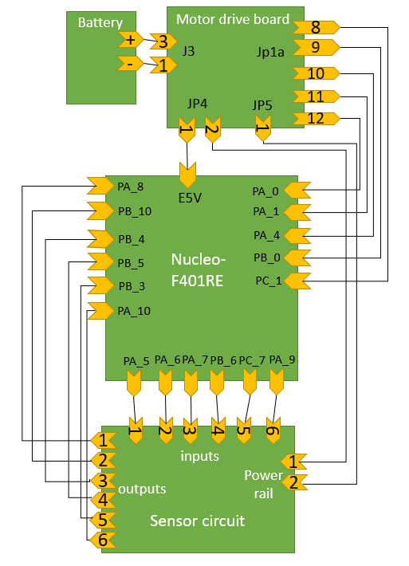

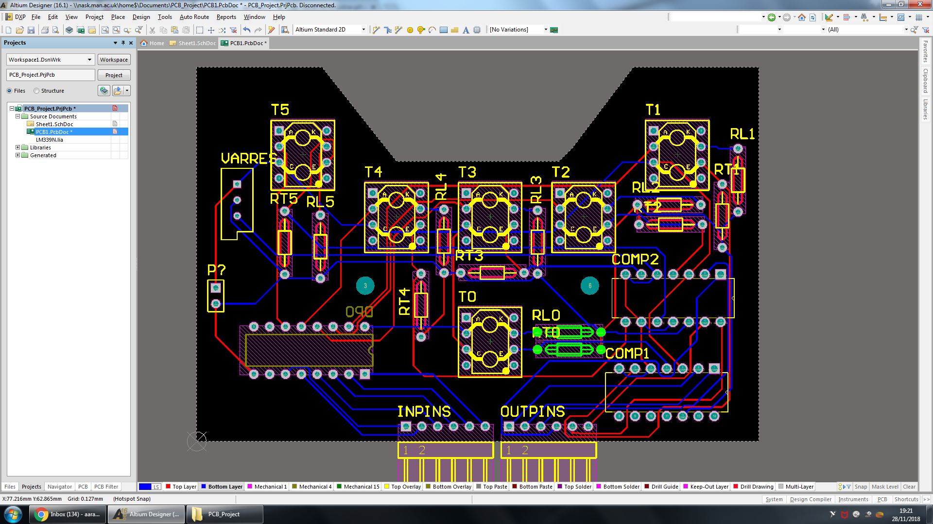

Figure Compiled schematic file to PCB using Altium Designer

Figure A block diagram suggesting interface between all peripherals and microcontroller.

With constraints decided by the chassis design, the dimensions of the sensor board were defined. The trapezium cut out at the top is designed to have sufficient space for the castor wheel (see 6.?). The positions of the sensors are followed by the decisions made in section 6.5. The rest of the design focuses on the efficiency of routing and minimising any overlap in routing. The design implements a double layer copper contact profile with components placed on both sides to simplify layout of components.

The battery will connect to the motor drive board using a 3 – way Molex connector. The current sensing voltage outputs, pins 9 to 12 of Jp1a will be outputted to the Nucleo ADC enabled I/O inputs to convert the analog voltage. Pin 8 of jp1a doesn’t need an ADC input as it outputs binary information but to keep the 5 wires together it is inputted into ADC enabled input. To provide power to the Nucleo board a 5 V 600 mA J3 pin 1 output feeds into the Vin pin where power can be inputted using a I/O pin. The sensors I/O outputs from the micro don’t need to be ADC enabled as they need logic signals to control the Darlington pairs. As for the sensor outputs, a comparator circuit outputs logic 0 and 1 signals so these will also be normal I/O inputs. Finally, the VDD 5 V output is inputted into the sensor circuit from the nucleo as the sensor circuit doesn’t need more than … and the limit of the Nucleo power rails current at 5V is 100 mA.